**Hosting a website**

Open Internet Information Service Manager (inetmgr.exe)

Expand->Sites->Default Web site

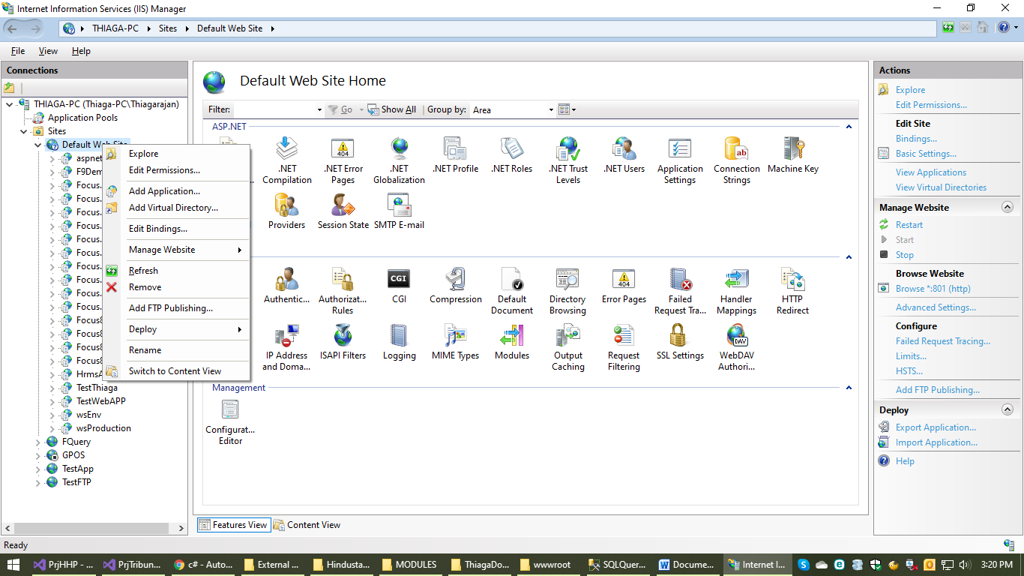

Right click on Default Website-> click add application.

Enter Alias as Security Engineers

If any other name given, module will not work. Map the path which should be available in **C:\inetpub\wwwroot**

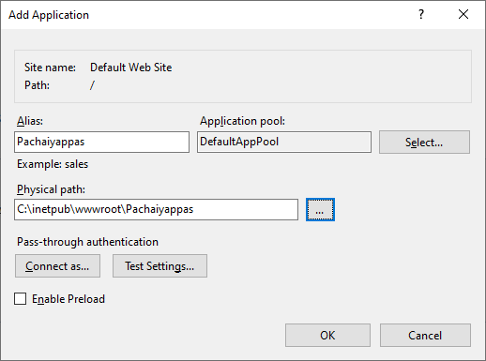

Click Ok. The website will be added like given below.

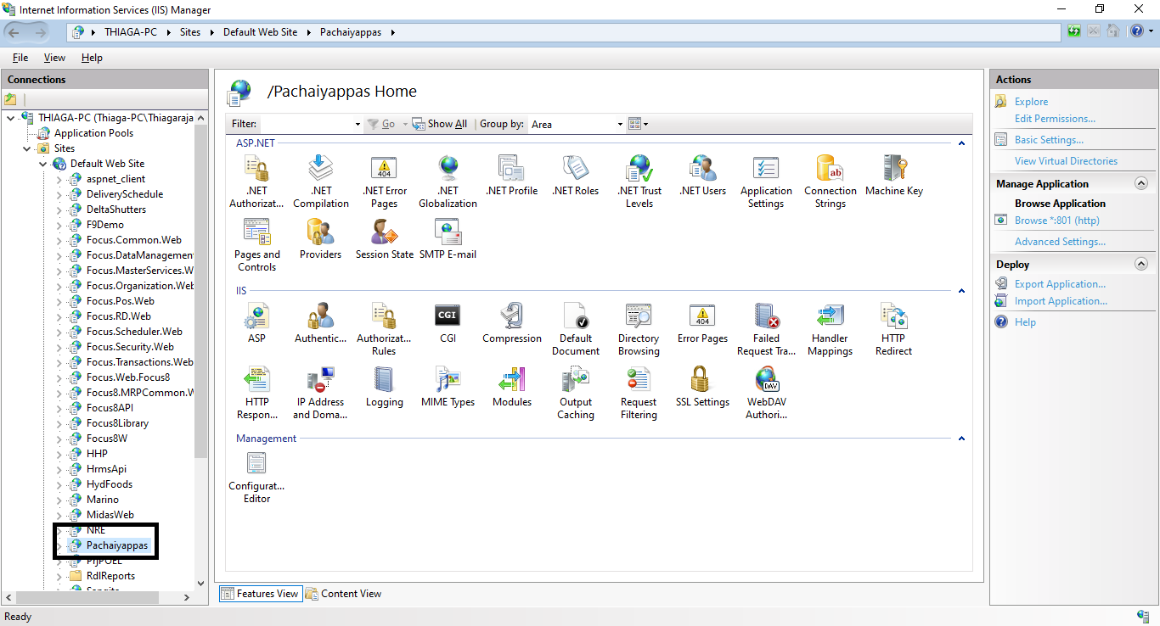

Open Security Engineers folder in **C:\inetpub\wwwroot** paste the files provided as given Below image.

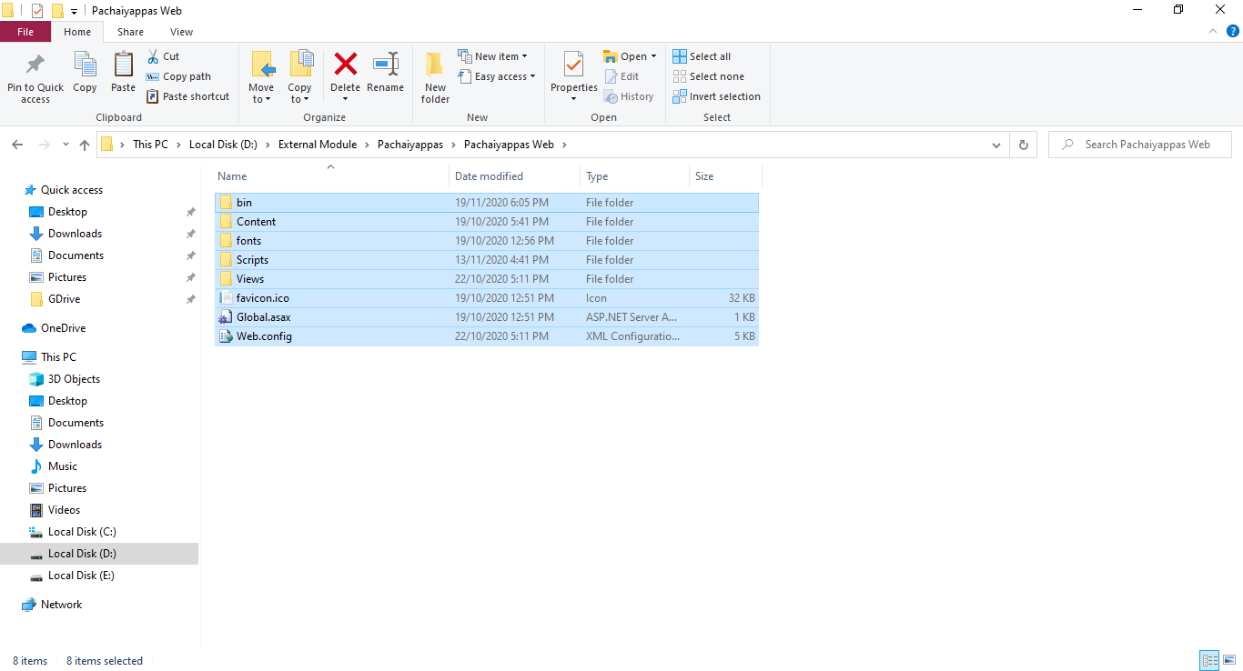

Open **C:\inetpub\wwwroot\** Security Engineers **\bin\XMLFILES**

Set **Data_Source, User_Id & Password** inDBConfig.xml

**Configuring Module in Focus 9 web**

**SO & MR Module Preferences**

Settings->Configure Transactions->External Modules

On Event - Menu

Menu Group - Select Menu Position

Module Type - URL

URL - /Security Engineers/WorkFlow/WorkFlow?iCompanyId=$CCode

$CCode is variable name donot change it

Click Insert. Update the settings

**SO & MR Module**

Settings->Configure Transactions->External Modules

On Event - Menu

Menu Group - Select Menu Position

Module Type - URL

URL - /Security Engineers/Module2/Module2?iCompanyId=$CCode

$CCode is variable name donot change it

Click Insert. Update the settings